Leonard Hales
Real Estate and Contents Auction

Tuesday, October 27th, 2015 at 3:30PM
4823 East Shelby Road, Shelby, NY

OFFERING AT PUBLIC AUCTION:

Colonial home on 2.1 country acres! This 1,500+ square foot Barden home has 3 bedrooms, two full baths and one half bath. Features a large living room with a fireplace and wood burning insert. This living room opens to a covered concrete patio through a newer sliding door. Kitchen with a small dining nook, second living arear and a dining area. Partial basement with concrete floor. House has a large 2 bay garage with overhead doors plus a workshop area and an office area. This large 2.1 acre parcel has municipal water and a lovely tree shaded lawn.
OPEN HOUSE: Thursday, October 22nd from 10am-Noon.
TERMS: $7,000 deposit due at auction. 10% buyer’s premium. Assessed at $121,800 this property sells subject to confirmation up to $40,000 and sells absolute over $40,000. See complete terms in this packet!

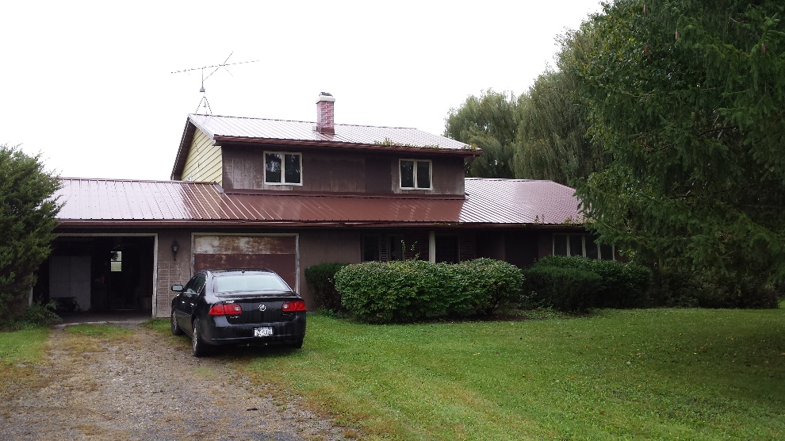

Property located approximately 2 miles south of Route 31A and Millville, and approximately 6 miles south east of Medina.
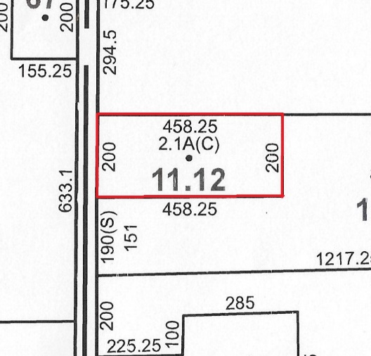

TAX MAP

NOTICE TO ALL BIDDERS

Township: Shelby 2015 Assessed Value: $121,800

County: Orleans School District: Medina

2014 Taxes: $5,346.59

The information included herewith is a summary of information available from a number of sources, most of which have not been independently verified. This summary has been provided only for the use of prospective bidders at Public Auction to be held on Tuesday October 27, 2015, in Shelby, New York, and is supplied for whatever assistance it may provide in answering questions; however: SUCH INFORMATION AND OPINIONS ARE SUPPLIED WITHOUT ANY WARRANTIES OR REPRESENTATIONS, EXPRESS OR IMPLIED WHATSOEVER.
Prospective bidders are advised to avail themselves of the land and tax records of Orleans County, Shelby township, and to make an inspection of the premises on their own behalf, consulting whatever advisors they may feel appropriate.
The property for sale will be auctioned in an “AS IS, WHERE IS” condition and neither the Auctioneer/Broker, WILLIAM KENT INC., nor the seller or their respective agents make any express or implied warranties of any kind. The description and conditions listed in this and other advertising materials are to be used as guidelines only, and are not guaranteed. Announcements made by the Auctioneer/Broker from the auction block at sale time will take precedence over ALL printed materials.

NOTICE TO ALL BIDDERS

- The TERMS OF THE SALE are all cash at time of Closing or otherwise as mutually agreed. The contract is not subject to condition of financing or any other contingencies. You must be sure that your financing is arranged, if needed, or that you are capable of paying cash at closing.

- This property sells subject to confirmation up to $40,000 and absolute over $40,000.

- Upon acceptance of the final bid, a $7,000 deposit will be required in cash or certified check made out to William Kent Inc. Brokers. This deposit will be held in Escrow. If the property fails to close due to no fault of the buyer, the deposit will be fully refunded.

- A Contract of Sale must be signed by the Buyer immediately following the Auction of Real Estate. The Buyer is also required to sign the Agency Disclosure, and Price Verification.

- The property sells in “AS IS” condition without exceptions. Compliance with any government regulations will be the responsibility of the buyer. Fixtures and appliances are sold in “AS IS” condition. Seller makes no representations or warranties, expressed or implied regarding the same.

- Seller will convey to buyer the premises by Warranty Deed.

- Property sells as per deed description.

- This Contract of Sale has been reviewed and approved by the Sellers’ attorney. When signed, the Contract of Sale becomes a binding contract. Buyers must review this Contract with their Attorney prior to bidding to obtain his or her written approval letter to present to the auctioneer at registration, or they must elect to waive Attorney approval.

- Announcements made from the Auction Block at the time of the sale will take precedence over all other information and all printed material. WILLIAM KENT INC. believes all material to be correct, but assumes no legal responsibility for its accuracy or for the accuracy of its representation.

BID PRICE $

PLUS 10% BUYER’S PREMIUM $

TOTAL PURCHASE PRICE $

By signing this verification, I/We, Buyer, agree and acknowledge that I/We understand how the total purchase price was computed. I/We also acknowledge that either my/our attorney approved the purchaser offer or I/We waive our attorney approval.

THIS AGREEMENT, made under the date of October 27, 2015, states, that SELLER, Leonard Hales, agrees to sell, and , BUYERS agree to buy the following Real Estate (Hereinafter referred to as “Property”).

- PROPERTY DESCRIPTION: Property located in the Town of Shelby, County of Orleans, State of New York, known as 4823 East Shelby Road and consisting of approximately 2.1 acres including all buildings, and any other improvements and all rights which the Seller has in the property, subject to all rights to streets, roads, highways, driveways, easements, leases, and rights-of-way:
  - Portion of Tax Map(s) #1103.-1-11.12
- PRICE: AMOUNT AND HOW IT WILL BE PAID: The purchase price will be dollars, and shall be paid all in cash or certified check at closing.

- DEPOSIT BY BUYER: Buyer has deposited $7,000 in the form of cash or check of the purchase price, to be deposited in the William Kent Inc. Broker Escrow account at M&T Bank, and which shall be applied to the purchase price. Purchaser agrees to pay the balance of the purchase price plus or minus prorations, at the time of closing by certified check or wire transfer, at the option of the seller. The earnest money is to be held by the broker in a non-interest bearing account, for the mutual benefit of the parties hereto, and paid over and applied to the payment of the purchase price at closing or returned to Buyer if not accepted.

- TITLE DOCUMENTS: Seller to furnish a Executor’s deed, at Seller’s expense, tax and title searches to time of transfer showing good, marketable title free of liens and encumbrances, except as above specified, and subject to pole and wire easements and restrictions running with the land common to the tract or subdivision. OBJECTION TO TITLE: If Purchaser raises a valid written objection to Seller’s title which indicates that the title to the Property is unmarketable, Seller may cancel this Contract by giving prompt written notice of cancellation to Purchaser and Purchaser’s Deposit shall be returned. However, if Seller is able to cure the title objection on or before the closing date, or if the title objection is insurable and Purchaser is willing to accept insurable title, then this Contract shall continue in force until the closing date, subject to the Seller curing the title objection and/or providing insurable title at Seller’s expense. If Seller fails to cure the title objection on or before the closing date, or if Purchaser is unwilling to accept insurable title, Purchaser may cancel this Contract by giving prompt written notice of cancellation to Seller. Taxes, interest, insurance, rents, and water to be adjusted to date of transfer. Uniform Purchaser’s-Vendors Risk Act shall apply. No representation in made concerning possible contamination; chemical, natural, or otherwise, which may or may not be present on the property.

- CLOSING DATE AND PLACE: The transfer of title to the property shall take place at the Orleans County Clerk’s Office on or before the 1st day of December, 2015.

- BUYER’S POSSESSION OF PROPERTY: Buyer shall be entitled to possession of the property at closing.

- FAILURE TO MAKE SETTLEMENT: Should the buyer fail to make settlement as herein provided, the sum paid down as deposit on account of the purchase price, at the option of the seller, may be retained by the Seller, either on account of the purchase money, or as liquidated damages. In the latter event, this agreement shall become null and void.

- LOT DESCRIPTION-ADVERTISING: Buyer acknowledges that lot sizes, acres of lots, and plan set forth in any circular and other advertising may not be accurate, and in signing this agreement Buyer relied on the description or plan set forth or referred to in this agreement.

- INSPECTION: Buyer acknowledges that he has entered into this agreement as the result of an inspection of said premises made by him and that said premises is being purchased as the result of that inspection.

- AGREEMENT: This agreement shall extend and be binding upon the heirs, administrators, successors, and assigns of the parties hereto.

- APPROVAL OF SELLER: The buyer acknowledges that this agreement is subject to the approval of Seller up to $40,000. Pending such approval Buyer shall be bound by this agreement with the same force and effect as if no such approval were required. If this agreement is not approved by Sellers, the deposit money paid on account hereof will be returned to Buyer, without interest, and this agreement shall become null and void.

- NOTICE: It is the policy of this state and this community to conserve, protect, and encourage the development and improvement of agricultural land for the production of food, and other products, and also for its natural and ecological value. This notice is to inform prospective residents that the property they are about to acquire may lie partially or totally within an agricultural district, and that farming activities occur within the district. Such farming activities may include, but not be limited to, activities that cause noise, dust, and odors.

- ENTIRE DOCUMENT: This contract (and other parts signed by Seller and Buyer), when completely filled out and when signed by both seller and buyer will be the record of the complete agreement between the Buyer and Seller concerning the purchase and sale of the property. No verbal agreements will be binding on either Buyer or Seller unless they are written down and signed by both Buyer and Seller.

Dated Buyer

Witness Buyer

ACCEPTANCE OF OFFER BY SELLER: Seller certifies that he-she own the property and have the power to sell the property. Seller accepts the offer and agrees to sell on the terms and conditions set forth in all parts of this purchase contract.

Dated Seller

Witness Seller

Buyer________________________ Seller________________________________
Address_______________________ Address______________________________
Phone________________________ Phone________________________________
Attorney______________________ Attorney______________________________

